**wBLOGENGINE .NET**

USE CASES

Users

|  |  |  |
| --- | --- | --- |
| Name: | admin | editor |
| Password: | admin | editor |

Main script

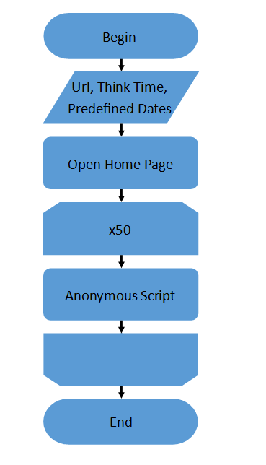

Anonymous script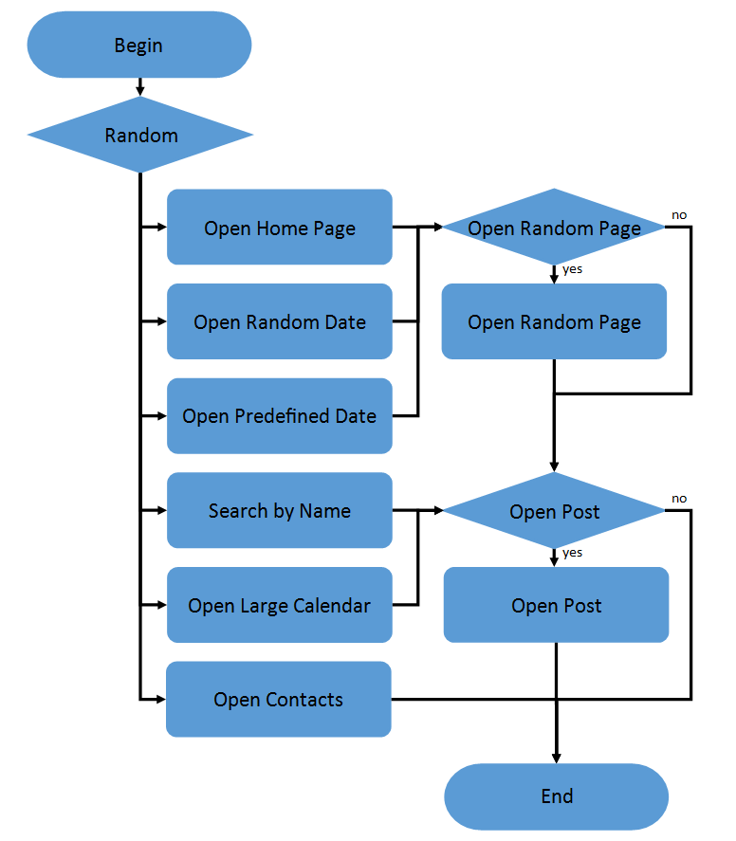

Open Post script

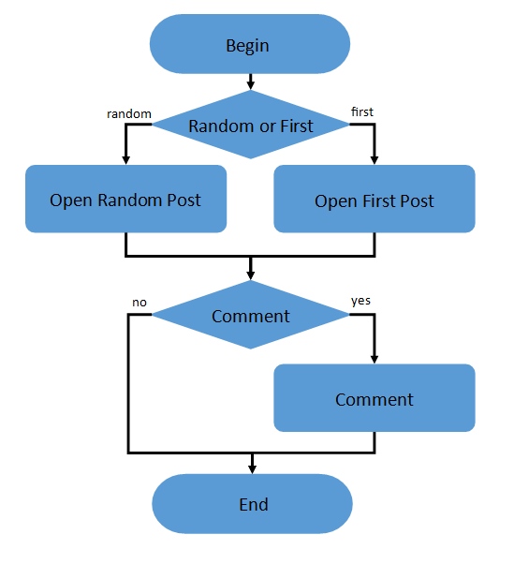

Admin script

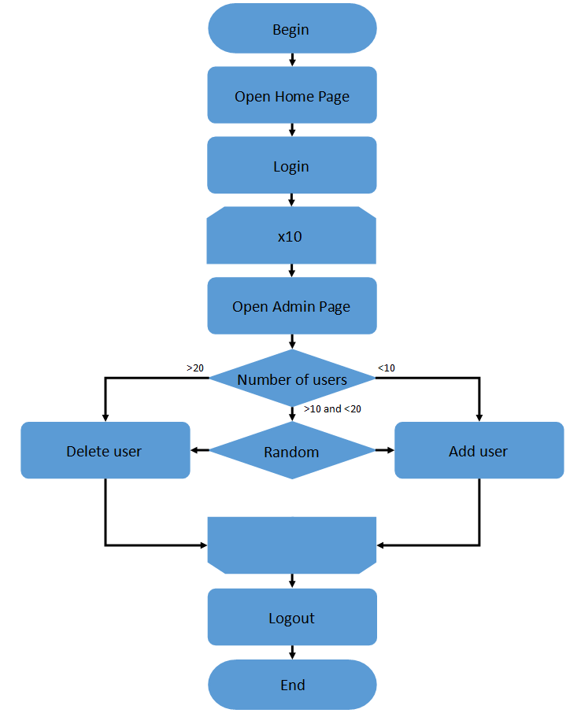

Editor script

